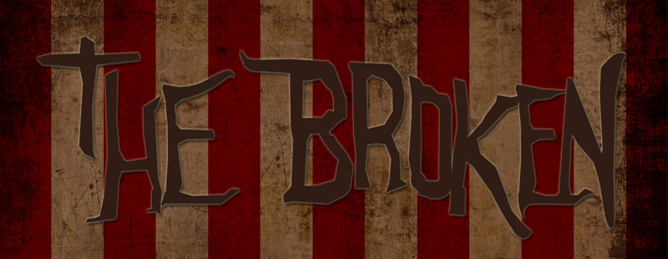
How God brings beauty out of the broken
Restore to me the joy of your salvation and grant me a willing spirit, to sustain me. Then I will teach transgressors your ways, so that sinners will turn back to you.
Psalm 51:12

3 KINDS OF BROKENNESS

1. THERE ARE THE BROKEN HEARTED.
2. THERE ARE THE BROKEN SPIRITED.
3. THERE ARE THOSE WITH BROKEN INTEGRITY.

WHAT WE DO

1. WE CONDEMN THEM
“For God did not send his Son into the world to condemn the world, but to save the world through him. Whoever believes in him is not condemned, but whoever does not believe stands condemned already because they have not believed in the name of God’s one and only Son.” JOHN 3:17-18

2. WE JUSTIFY THEM
3. WE INGNOR/ISOLATE THEM
4. WE FEAR THEM
“Then Nathan said to David, ‘You are the man! This is what the LORD, the God of Israel, says: “I anointed you king over Israel, and I delivered you from the hand of Saul. I gave your master’s house to you, and your master’s wives into your arms. I gave you all Israel and Judah. And if all this had been too little, I would have given you even more. Why did you despise the word of the LORD by doing what is evil in his eyes?”’” 2 Samuel 12-7-9

WHAT GOD DOES

1. GOD’S MERCY SUSTAINS US
2. GOD’S LOVE REDEEMS US
3. GOD’S GRACE RESTORES US
4. GOD’S PROVIDENCE SHAPES US

WHAT YOU DO

“If we claim to be without sin, we deceive ourselves and the truth is not in us. If we confess our sins, he is faithful and just and will forgive us our sins and purify us from all unrighteousness.” 1 John 1:8-9

YOU MUST OWN UP, SPEAK UP, AND SHOW UP.

How God brings beauty out of the broken
Restore to me the joy of your salvation and grant me a willing spirit, to sustain me. Then I will teach transgressors your ways, so that sinners will turn back to you.
Psalm 51:12

3 KINDS OF BROKENNESS

1. THERE ARE THE BROKEN _______________
2. THERE ARE THE BROKEN _______________
3. THERE ARE THOSE WITH BROKEN _______________
WHAT WE DO

1. WE _______________ THEM
“For God did not send his Son into the world to condemn the world, but to save the world through him. Whoever believes in him is not condemned, but whoever does not believe stands condemned already because they have not believed in the name of God’s one and only Son.” JOHN 3;17-18

2. WE _______________THEM
3. WE ______________________________THEM
4. WE _______________ THEM
“Then Nathan said to David, ‘You are the man! This is what the LORD, the God of Israel, says: “I anointed you king over Israel, and I delivered you from the hand of Saul. I gave your master’s house to you, and your master’s wives into your arms. I gave you all Israel and Judah. And if all this had been too little, I would have given you even more. Why did you despise the word of the LORD by doing what is evil in his eyes?”’” 2 Samuel 12-7-9

WHAT GOD DOES

1. GOD’S ______________________________US
2. GOD’S ______________________________US
3. GOD’S ______________________________US
4. GOD’S ______________________________US

WHAT YOU DO

“If we claim to be without sin, we deceive ourselves and the truth is not in us. If we confess our sins, he is faithful and just and will forgive us our sins and purify us from all unrighteousness.” 1 John 1:8-9

YOU MUST _____________________________________________.

Small Group Questions

- Have you ever judged someone incorrectly? What happened?

- What mistakes have you made that you hope no one will bring up 20 years from now?

- Read Matthew 7:1-2

- How does judging people hurt them? hurt you?

- How should you treat a person with a questionable past?

- Who have you been judging recently that you need to seek forgiveness from?

